Exercise 1: Control Structures

-- Create Customers Table

CREATE TABLE Customers (

CustomerID NUMBER PRIMARY KEY,

Name VARCHAR2(100),

DOB DATE,

Balance NUMBER,

LastModified DATE

);

-- Add IsVIP column for Scenario 2

ALTER TABLE Customers ADD IsVIP CHAR(1);

-- Create Accounts Table

CREATE TABLE Accounts (

AccountID NUMBER PRIMARY KEY,

CustomerID NUMBER,

AccountType VARCHAR2(20),

Balance NUMBER,

LastModified DATE,

FOREIGN KEY (CustomerID) REFERENCES Customers(CustomerID)

);

-- Create Transactions Table

CREATE TABLE Transactions (

TransactionID NUMBER PRIMARY KEY,

AccountID NUMBER,

TransactionDate DATE,

Amount NUMBER,

TransactionType VARCHAR2(10),

FOREIGN KEY (AccountID) REFERENCES Accounts(AccountID)

);

-- Create Loans Table

CREATE TABLE Loans (

LoanID NUMBER PRIMARY KEY,

CustomerID NUMBER,

LoanAmount NUMBER,

InterestRate NUMBER,

StartDate DATE,

EndDate DATE,

FOREIGN KEY (CustomerID) REFERENCES Customers(CustomerID)

);

-- Create Employees Table

CREATE TABLE Employees (

EmployeeID NUMBER PRIMARY KEY,

Name VARCHAR2(100),

Position VARCHAR2(50),

Salary NUMBER,

Department VARCHAR2(50),

HireDate DATE

);

INSERT INTO Customers (CustomerID, Name, DOB, Balance, LastModified)

VALUES (1, 'John Doe', TO_DATE('1955-05-15', 'YYYY-MM-DD'), 12000, SYSDATE);

INSERT INTO Customers (CustomerID, Name, DOB, Balance, LastModified)

VALUES (2, 'Jane Smith', TO_DATE('1990-07-20', 'YYYY-MM-DD'), 8000, SYSDATE);

INSERT INTO Customers (CustomerID, Name, DOB, Balance, LastModified)

VALUES (3, 'Robert White', TO_DATE('1940-02-11', 'YYYY-MM-DD'), 15000, SYSDATE);

INSERT INTO Customers (CustomerID, Name, DOB, Balance, LastModified)

VALUES (4, 'Emily Green', TO_DATE('1988-12-01', 'YYYY-MM-DD'), 9500, SYSDATE);

INSERT INTO Customers (CustomerID, Name, DOB, Balance, LastModified)

VALUES (5, 'Anil Mehra', TO_DATE('1963-03-05', 'YYYY-MM-DD'), 10500, SYSDATE);

-- Insert Accounts

INSERT INTO Accounts (AccountID, CustomerID, AccountType, Balance, LastModified)

VALUES (1, 1, 'Savings', 1000, SYSDATE);

INSERT INTO Accounts (AccountID, CustomerID, AccountType, Balance, LastModified)

VALUES (2, 2, 'Checking', 8000, SYSDATE);

INSERT INTO Accounts (AccountID, CustomerID, AccountType, Balance, LastModified)

VALUES (3, 3, 'Savings', 15000, SYSDATE);

INSERT INTO Accounts (AccountID, CustomerID, AccountType, Balance, LastModified)

VALUES (4, 4, 'Savings', 9500, SYSDATE);

INSERT INTO Accounts (AccountID, CustomerID, AccountType, Balance, LastModified)

VALUES (5, 5, 'Checking', 10500, SYSDATE);

-- Insert Loans

INSERT INTO Loans (LoanID, CustomerID, LoanAmount, InterestRate, StartDate, EndDate)

VALUES (1, 1, 5000, 5, SYSDATE, SYSDATE + 15);

INSERT INTO Loans (LoanID, CustomerID, LoanAmount, InterestRate, StartDate, EndDate)

VALUES (2, 2, 8000, 6, SYSDATE, SYSDATE + 40);

INSERT INTO Loans (LoanID, CustomerID, LoanAmount, InterestRate, StartDate, EndDate)

VALUES (3, 3, 20000, 7, SYSDATE, SYSDATE + 25);

INSERT INTO Loans (LoanID, CustomerID, LoanAmount, InterestRate, StartDate, EndDate)

VALUES (4, 4, 15000, 5.5, SYSDATE, SYSDATE + 90);

INSERT INTO Loans (LoanID, CustomerID, LoanAmount, InterestRate, StartDate, EndDate)

VALUES (5, 5, 18000, 6.2, SYSDATE, SYSDATE + 10);

-- Insert Employees

INSERT INTO Employees (EmployeeID, Name, Position, Salary, Department, HireDate)

VALUES (1, 'Alice Johnson', 'Manager', 70000, 'HR', TO_DATE('2015-06-15', 'YYYY-MM-DD'));

INSERT INTO Employees (EmployeeID, Name, Position, Salary, Department, HireDate)

VALUES (2, 'Bob Brown', 'Developer', 60000, 'IT', TO_DATE('2017-03-20', 'YYYY-MM-DD'));

INSERT INTO Employees (EmployeeID, Name, Position, Salary, Department, HireDate)

VALUES (3, 'Priya Kumar', 'Clerk', 40000, 'Finance', TO_DATE('2019-11-01', 'YYYY-MM-DD'));

Scenario 1 :

BEGIN

FOR loan_rec IN (

SELECT l.LoanID, l.InterestRate, c.DOB

FROM Loans l

JOIN Customers c ON l.CustomerID = c.CustomerID

) LOOP

IF MONTHS_BETWEEN(SYSDATE, loan_rec.DOB) / 12 > 60 THEN

UPDATE Loans

SET InterestRate = InterestRate - 1

WHERE LoanID = loan_rec.LoanID;

END IF;

END LOOP;

COMMIT;

END;

/

Output :

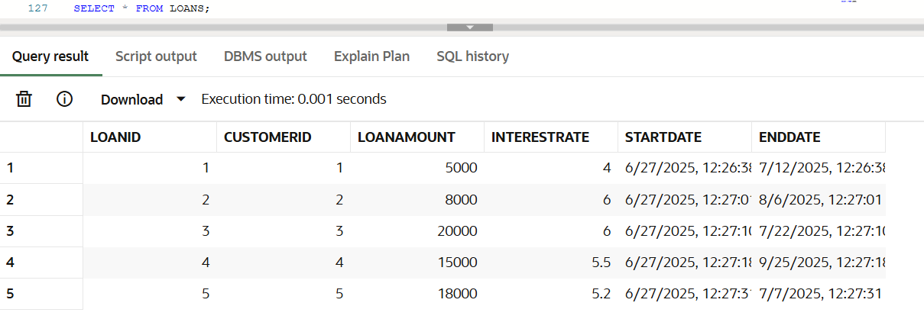

Scenario 2 :

BEGIN

FOR cust_rec IN (SELECT CustomerID, Balance FROM Customers) LOOP

IF cust_rec.Balance > 10000 THEN

UPDATE Customers

SET IsVIP = 'Y'

WHERE CustomerID = cust_rec.CustomerID;

END IF;

END LOOP;

COMMIT;

END;

/

Output :

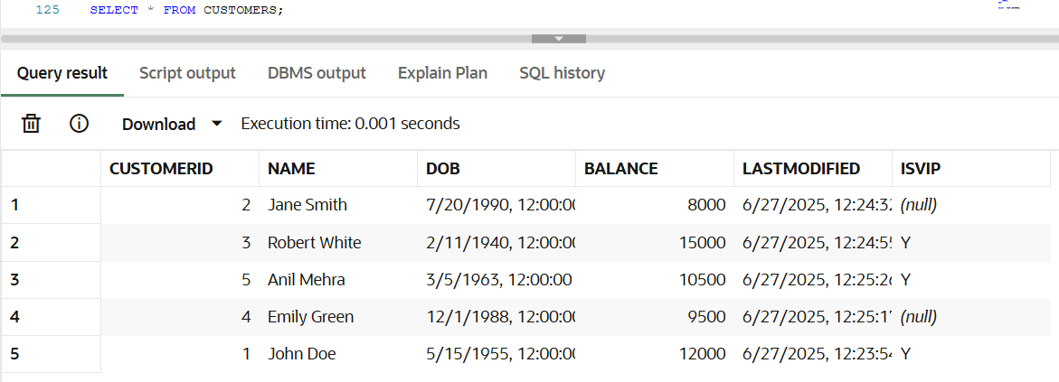

Scenario 3 :

BEGIN

FOR loan_rec IN (

SELECT l.LoanID, l.EndDate, c.Name

FROM Loans l

JOIN Customers c ON l.CustomerID = c.CustomerID

WHERE l.EndDate BETWEEN SYSDATE AND SYSDATE + 30

) LOOP

DBMS_OUTPUT.PUT_LINE('Reminder: Loan ID ' || loan_rec.LoanID ||

' for customer ' || loan_rec.Name ||

' is due on ' || TO_CHAR(loan_rec.EndDate, 'YYYY-MM-DD'));

END LOOP;

END;

/

Output :

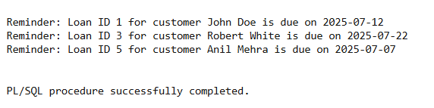

Exercise 3: Stored Procedures

CREATE TABLE Customers (

CustomerID NUMBER PRIMARY KEY,

Name VARCHAR2(100),

DOB DATE,

Balance NUMBER,

LastModified DATE

);

CREATE TABLE Accounts (

AccountID NUMBER PRIMARY KEY,

CustomerID NUMBER,

AccountType VARCHAR2(20),

Balance NUMBER,

LastModified DATE,

FOREIGN KEY (CustomerID) REFERENCES Customers(CustomerID)

);

CREATE TABLE Transactions (

TransactionID NUMBER PRIMARY KEY,

AccountID NUMBER,

TransactionDate DATE,

Amount NUMBER,

TransactionType VARCHAR2(10),

FOREIGN KEY (AccountID) REFERENCES Accounts(AccountID)

);

CREATE TABLE Loans (

LoanID NUMBER PRIMARY KEY,

CustomerID NUMBER,

LoanAmount NUMBER,

InterestRate NUMBER,

StartDate DATE,

EndDate DATE,

FOREIGN KEY (CustomerID) REFERENCES Customers(CustomerID)

);

CREATE TABLE Employees (

EmployeeID NUMBER PRIMARY KEY,

Name VARCHAR2(100),

Position VARCHAR2(50),

Salary NUMBER,

Department VARCHAR2(50),

HireDate DATE

);

-- Existing Data

INSERT INTO Customers VALUES (1, 'John Doe', TO_DATE('1985-05-15', 'YYYY-MM-DD'), 1000, SYSDATE);

INSERT INTO Customers VALUES (2, 'Jane Smith', TO_DATE('1990-07-20', 'YYYY-MM-DD'), 1500, SYSDATE);

INSERT INTO Accounts VALUES (1, 1, 'Savings', 1000, SYSDATE);

INSERT INTO Accounts VALUES (2, 2, 'Checking', 1500, SYSDATE);

INSERT INTO Transactions VALUES (1, 1, SYSDATE, 200, 'Deposit');

INSERT INTO Transactions VALUES (2, 2, SYSDATE, 300, 'Withdrawal');

INSERT INTO Loans VALUES (1, 1, 5000, 5, SYSDATE, ADD_MONTHS(SYSDATE, 60));

INSERT INTO Employees VALUES (1, 'Alice Johnson', 'Manager', 70000, 'HR', TO_DATE('2015-06-15', 'YYYY-MM-DD'));

INSERT INTO Employees VALUES (2, 'Bob Brown', 'Developer', 60000, 'IT', TO_DATE('2017-03-20', 'YYYY-MM-DD'));

-- Extra Data

INSERT INTO Customers VALUES (3, 'Emily Davis', TO_DATE('1992-08-10', 'YYYY-MM-DD'), 2000, SYSDATE);

INSERT INTO Accounts VALUES (3, 3, 'Savings', 2000, SYSDATE);

INSERT INTO Accounts VALUES (4, 1, 'Checking', 500, SYSDATE);

INSERT INTO Employees VALUES (3, 'Charlie Green', 'Analyst', 55000, 'Finance', TO_DATE('2019-04-10', 'YYYY-MM-DD'));

INSERT INTO Employees VALUES (4, 'Diana Stone', 'Tester', 50000, 'IT', TO_DATE('2020-09-25', 'YYYY-MM-DD'));

Scenario 1 :

CREATE OR REPLACE PROCEDURE ProcessMonthlyInterest AS

BEGIN

UPDATE Accounts

SET Balance = Balance * 1.01,

LastModified = SYSDATE

WHERE AccountType = 'Savings';

END;

Output :

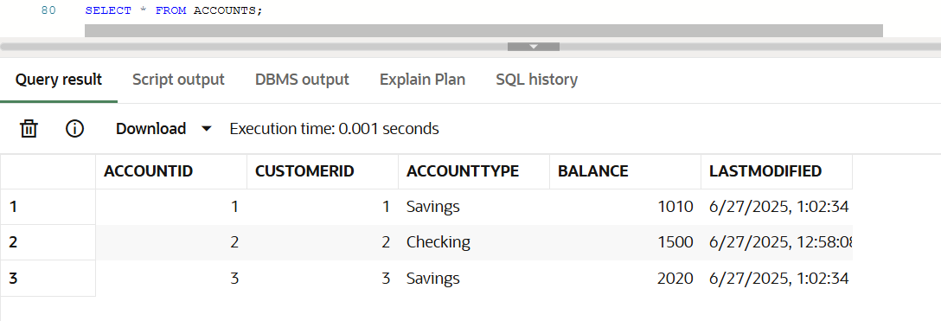

Scenario 2 :

CREATE OR REPLACE PROCEDURE UpdateEmployeeBonus(

dept IN VARCHAR2,

bonus_percent IN NUMBER

) AS

BEGIN

UPDATE Employees

SET Salary = Salary + (Salary * bonus_percent / 100)

WHERE Department = dept;

END;

Output :

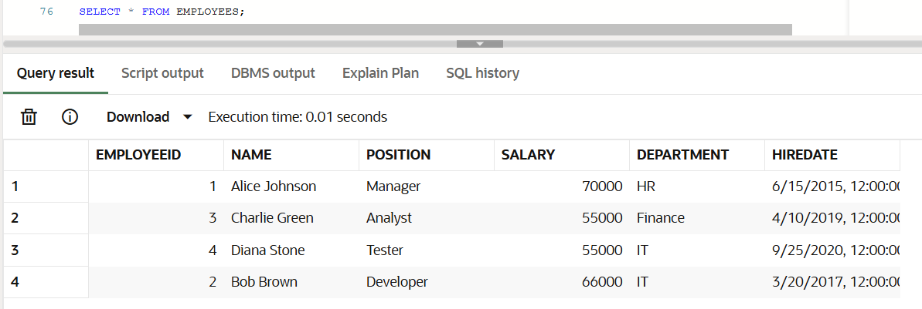

Scenario 3 :

CREATE OR REPLACE PROCEDURE TransferFunds(

from_account IN NUMBER,

to_account IN NUMBER,

amount IN NUMBER

) AS

insufficient_funds EXCEPTION;

source_balance NUMBER;

BEGIN

SELECT Balance INTO source_balance

FROM Accounts

WHERE AccountID = from_account

FOR UPDATE;

IF source_balance < amount THEN

RAISE insufficient_funds;

END IF;

UPDATE Accounts

SET Balance = Balance - amount,

LastModified = SYSDATE

WHERE AccountID = from_account;

UPDATE Accounts

SET Balance = Balance + amount,

LastModified = SYSDATE

WHERE AccountID = to_account;

INSERT INTO Transactions (TransactionID, AccountID, TransactionDate, Amount, TransactionType)

VALUES (TRANSACTIONS_SEQ.NEXTVAL, from_account, SYSDATE, amount, 'Debit');

INSERT INTO Transactions (TransactionID, AccountID, TransactionDate, Amount, TransactionType)

VALUES (TRANSACTIONS_SEQ.NEXTVAL, to_account, SYSDATE, amount, 'Credit');

EXCEPTION

WHEN insufficient_funds THEN

DBMS_OUTPUT.PUT_LINE('Insufficient balance in the source account.');

WHEN OTHERS THEN

DBMS_OUTPUT.PUT_LINE('Unexpected error: ' || SQLERRM);

END;

Output :

